Question 1. Describe the data structure used to record the EEG signals.
Code and result
- The P_C_S data contains 91 filed as followed
disp(fieldnames(P_C_S));
{'version' }
{'channels' }
{'channelname' }
{'lowpass' }
{'highpass' }
{'notch' }
{'unit' }
{'numberchannels' }
{'amplifiername' }
{'sens' }
{'data' }
{'samplingfrequency' }
{'subjectlastname' }
{'subjectfirstname' }
{'subjectid' }
{'subjectbirthday' }
{'subjectdiagnosis' }
{'subjectmedication' }
{'subjectcomment' }
{'subjecthand' }
{'subjectsex' }
{'subjectage' }
{'companyname' }
{'companyinstitute' }
{'companydepartment' }
{'companyinvestigator' }
{'companyoperator' }
{'companycopyright' }
{'companyyear' }
{'companylogo' }
{'sessionnumber' }
{'sessiontime' }
{'sessiondate' }
{'sessionstudyname' }
{'sessioncomment' }
{'paradigmname' }
{'paradigmrun' }
{'paradigmcondition' }
{'paradigmisi' }
{'paradigmcomment' }
{'paradigminfo' }
{'daqboard' }
{'daqresolution' }
{'daqboardname' }
{'daqchannels' }
{'daqsamplingfrequency' }
{'physicalvalue' }
{'matlabvalue' }
{'channeltype' }
{'attribute' }
{'attributename' }
{'attributecolor' }
{'marker' }
{'markername' }
{'markercolor' }
{'channelattribute' }
{'channelattributename' }
{'channelattributecolor'}
{'filename' }
{'videofile' }
{'workdata' }
{'trialnumber' }
{'pretrigger' }
{'posttrigger' }
{'xposition' }
{'yposition' }
{'zposition' }
{'montagename' }
{'trialexclude' }
{'channelexclude' }
{'channelscaling' }
{'positivenegative' }
{'displayseconds' }
{'displaychannels' }
{'displaytrials' }
{'gotosecond' }
{'gotochannel' }
{'gototrial' }
{'physicalunit' }
{'scalingsens' }
{'scalingunit' }
{'epochingselect' }
{'epochingname' }
{'epochingcolor' }
{'analizingdata' }
{'editcommentnumber' }
{'comment' }
{'vruler_value1' }
{'vruler_value2' }
{'hruler_value1' }
{'hruler_value2' }
- Specifically,描述
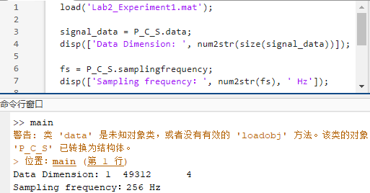

Question 2.

Seems like the file saved in experiment 1 already remove the DC, so here I used data in experiment 2-2 (remove all the filters) to exhibit the result of eliminating DC

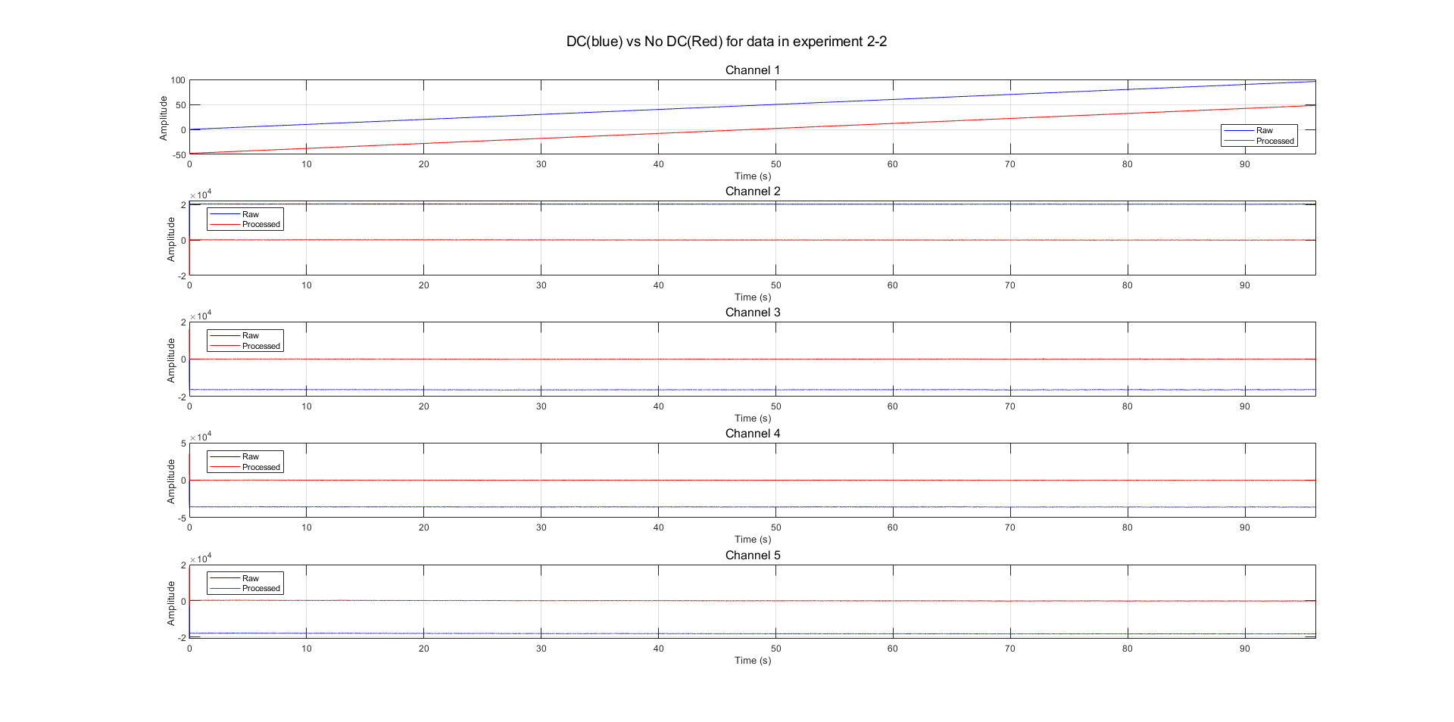
Remove dc
time-domain average power sitting: 0.000559
time-domain average power Blinking: 0.000147
time-domain average power Rolling: 0.015730
time-domain average power Chewing: 0.018897
time-domain average power Tensing: 0.000292
time-domain average power Touching: 0.006396

beta
time-domain average power sitting: 0.002320
time-domain average power Blinking: 0.000666
time-domain average power Rolling: 0.062253
time-domain average power Chewing: 0.103921
time-domain average power Tensing: 0.012802
time-domain average power Touching: 0.039249

